Lord Rennard MBE
House of Lords
London
SW1A 0PW

Charlotte Harris,
Liberal Democrat HQ,
8 – 10 Great George Street,
London SW1P 3AE.

Monday, 26 May 2014

For the immediate attention of the English Appeals Panel

Dear Charlotte,

I am in receipt of the letter from Steeles Law sent by e-mail on the afternoon of Friday 23rd May 2014. As you will be aware, Richard Cannon of Janes has replied to say that it will not be possible to provide a substantive reply until we have met on Wednesday 28th May.

In the meantime, a query was raised as to whether or not the apology included on page 14 of my appeal document (Rennard EAP 060514) should be transmitted by the English Party to the four complainants. For ease of reference, this is as below:

Apology on behalf of Lord Rennard

Lord Rennard wishes to achieve closure of the contentious issues that have been in the public domain for the last fourteen months by expressing his apologies to Susan Gaszczak, Alison Goldsworthy, Bridget Harris and Alison Smith.

Lord Rennard personally accepts the full report of Alistair Webster QC as given to him on March 7th in its entirety. Whilst Alistair Webster QC’s report made absolutely no requirements of Lord Rennard, or made any recommendations whatsoever concerning him, he does recognise as suggested in the full report, that he may well have encroached upon “personal space”. In relation to this, Alistair Webster suggested in his report that Lord Rennard “may well wish to consider an apology”. He would therefore like to apologise sincerely for any such intrusion and assure them that this would have been inadvertent.

He hereby expresses his regret for any harm or embarrassment caused to them or anything which made them feel uncomfortable. Lord Rennard wishes to make it absolutely clear that it was never his intention to cause distress or concern to them by anything that he ever said or did. He also hopes that they will accept that the events of the last fourteen months have been a most unhappy experience for him, his family and friends and for the party.

I would be most grateful if the English Party could transmit this immediately, now that we are past polling day, and confirm to me when this has been done.

Please may I assume that the Chairs of the English Party, the English Appeals Panel and the Regional Parties Committee are all made aware of this communication.

Many thanks for your assistance.

Yours faithfully,

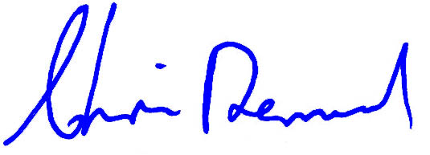
Lord Rennard

